ngrx-redux pattern…



Angular Question and answer

----------------------------------

why do we need CLI - compilation steps , bundle,minify,code splitting(lazy loading) will be using webpack

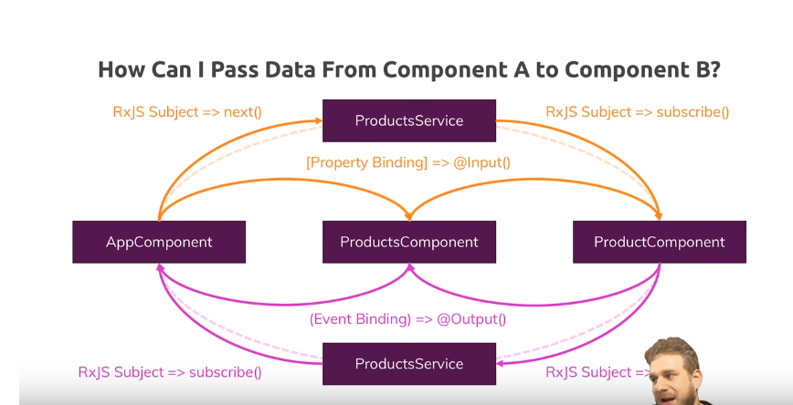

From parent to child only. If you want to pass data from parent to sub-child(ex appcomponet directly to proctcomponent) use RxJS and don’t forget to unsbscrib in order to avoid memory leak.

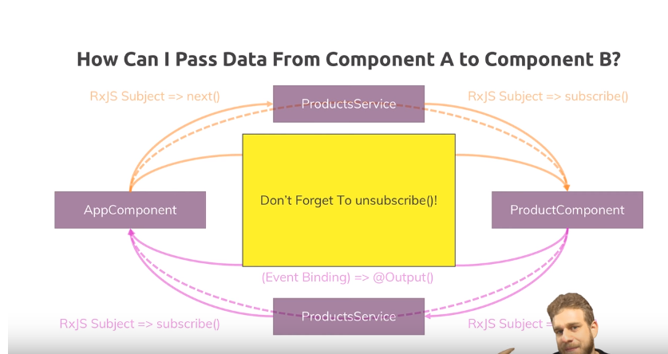

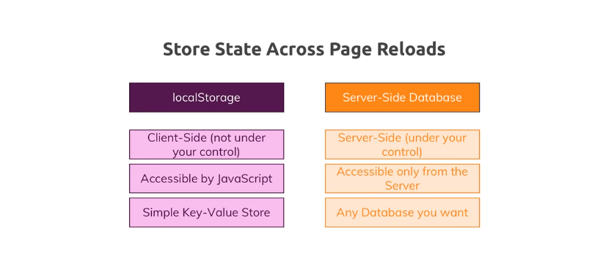

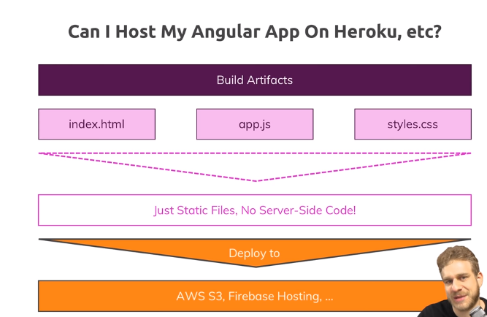

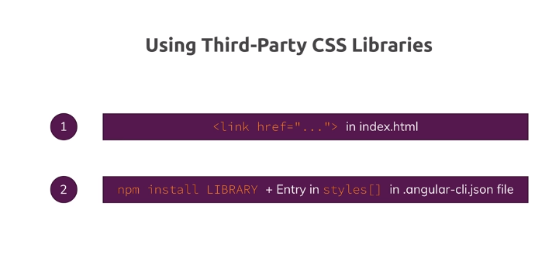

Declaration will translate the java script functionality to Type script file so use declare in typings.d.ts as below.

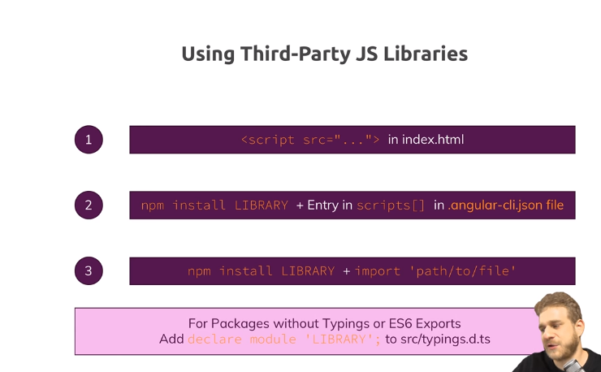

Example:::::

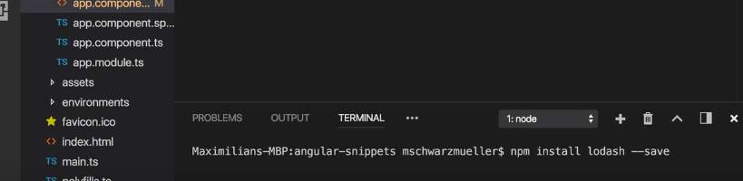

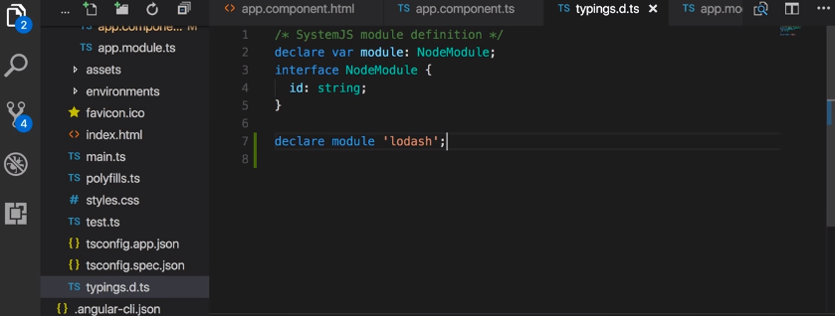

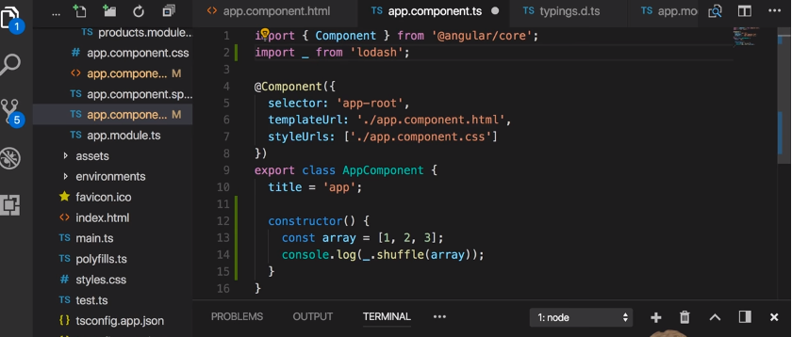

What is webpack? Is build tool, manage our codes,

Why do we need this.

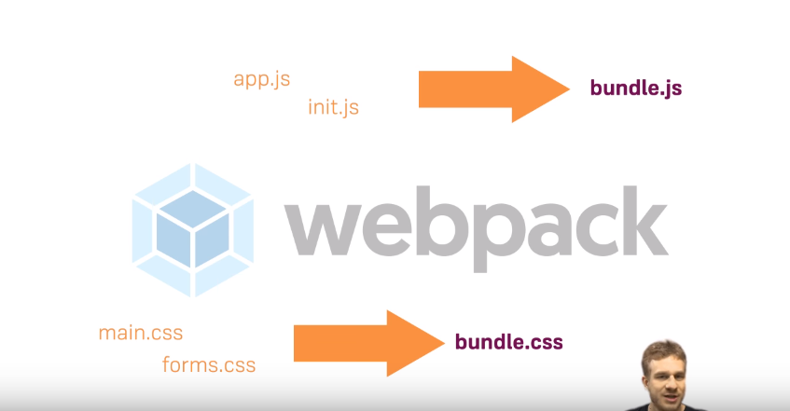

What is RXJS





What is Observable

Callbacks vs Promises vs RxJs Observables vs async/ await

https://www.youtube.com/watch?v=jgWnccjXR4I

Handling async operations is a common task in any JavaScript program, NESTING CAN BE REMOVE, ERROR HANDLING EASY.

PROMISE IS NATIVE JAVA SCRIPT, IT CAN HANDLE ONE REQUEST ONLY. RXJS IS NOT IT COME WITH EXTERNAL LIBRARY, IT CAN HANDLE STREAM OF DATA/REQUEST. has many operators. once chain end we have to subscribe. Async/await use promise

# SPAs vs MPAs/MVC - Are Single Page Apps always better?

MPA – every time it download the page . watch the refresh icon in browser.

SPA – only that particular dom change.

Search engine optimatization is chanllanging.

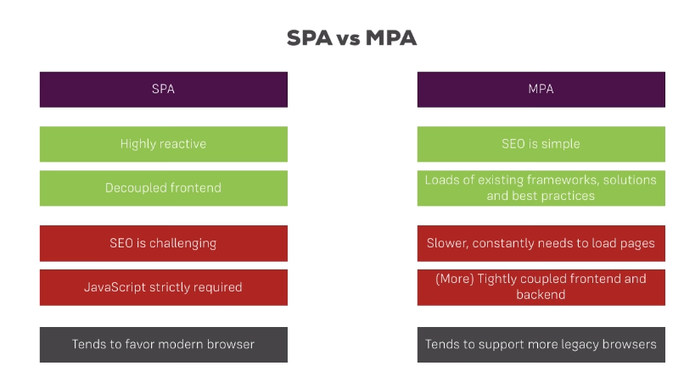

Angular 2- feature --- use typescript( ),generics,Dependency injection, component based( controllers and $scope are replaced. Replaced by components and directives(is class which contain metadata attached to class by the @Directive decorator, it change dom layout by adding & removing DOM, it change the apparence or behavior of an elements , components or other directives .3types – Component, structural and attribute directive).pipes (way to transform and format data from your templates.)

1. When rendering the page for the first time, which file is called first? Answer: main.ts file will be called first. In this file app component to be bootstrapped is called. 2. What changes need to done in the app.module.ts file if we create a component/directives manually? i.e. without using cli command line tool Answer: First import the component/directive Then in declarations add the component/directive name 3. Different types of decorators or list few decorators Answer: Class Decorators - @NgModule, @Component, @Directive Property Decorators - @Input, @Output Method Decorators - @HostListener, @HostBinding Parameter Decorators - @Inject 4. What are the Mandatory objects that must be defined in component Decorators Answer: selector and templateUrl/template 5. How decorators should be defined in .ts file for example in component Decorator Answer: @Component ({ selector: 'app-port', template: './port.component.html', styles: ['./port.component.css'] }) 6. Different types of component selector Answer: Element selector - selector: ‘app-test’ In html Class selector - selector: ‘.app-test’ In html Property selector - selector: ‘[app-test]’ In html We don’t have Id selector in angular 7. how many html file in templateUrl object can be given to a component decorator Answer: Only one html file can be given in templateUrl object 8. What is data binding? Answer: It’s nothing but the communication between .ts file and the html file. Say for example, you have done some logical implementation in the ts and that you want to show it in the html template. 9. Different type of data binding. Answer: String Interpolation Property binding Event binding Two way data binding 10. What is a String interpolation? Explain with a syntax Answer: It’s outputting the data in template/html file from ts file as string and this should always be a string. Syntax: {{data}} 11. What is property binding? Explain with a syntax Answer: It’s binding the value to a property of the DOM element. Syntax: [propertyName] =”data” 12. what is event binding? Explain with a syntax Answer: It’s binding the value to an event of a DOM element Syntax: (change) ="onChoosingPort ()" 13. What is Two way data binding? Explain with a syntax Answer: It’s binding the data value both side. I.e. assigning the property value from type script to template and on changing the value in template assigning the value to type script file. Syntax :[(ngModel)] =”data” 14. What are the different types of Built in Directives available in Angular Answer: Structural directives: ngIf & ngFor Attribute directives: ngStyle & ngClass

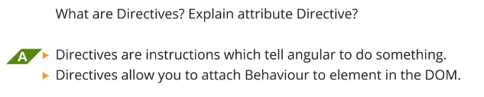

How are events attached to Directive? Using @HostListener directive

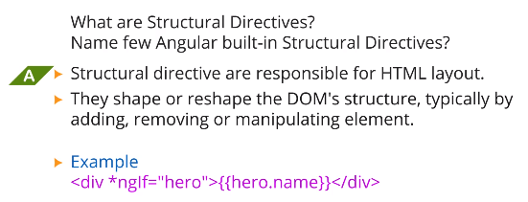

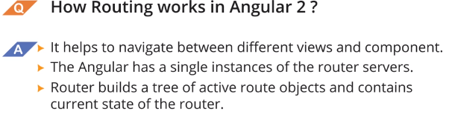

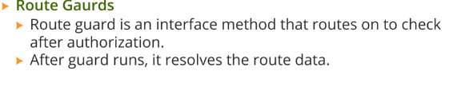

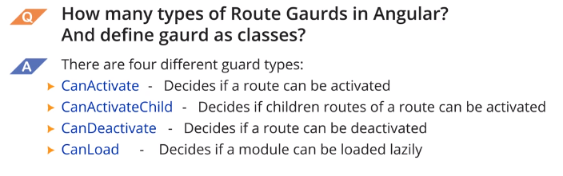

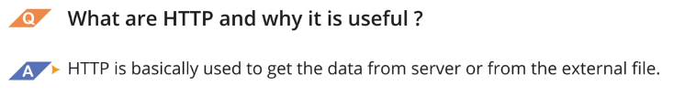

How do we handle external HTTP error and response?

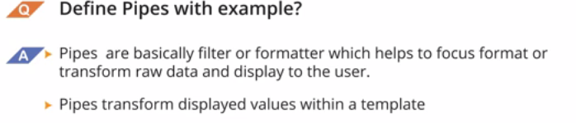

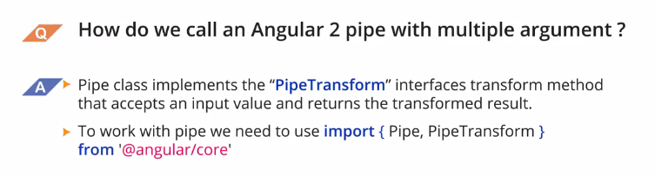



Define pure and impure pipe?

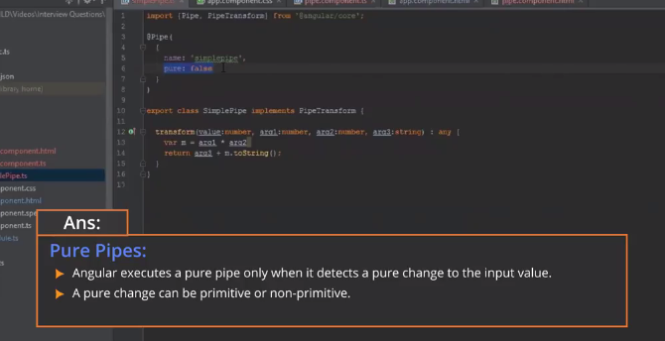

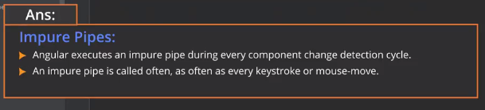

Which directives are used in Angular forms? ngForm

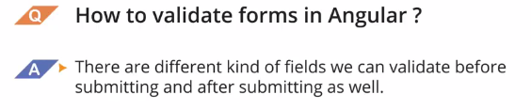

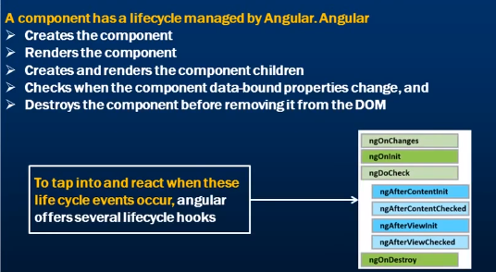s

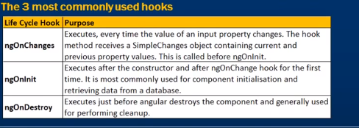

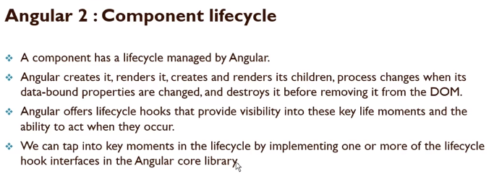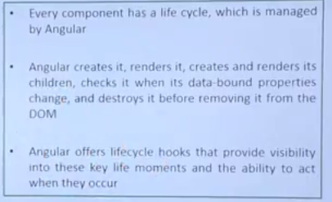

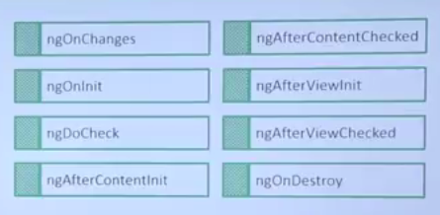

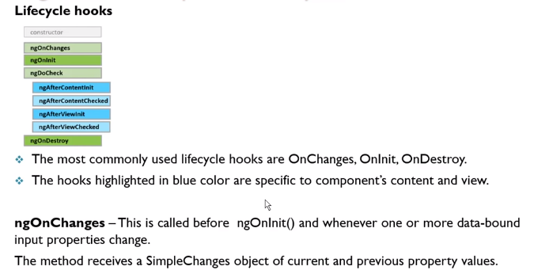

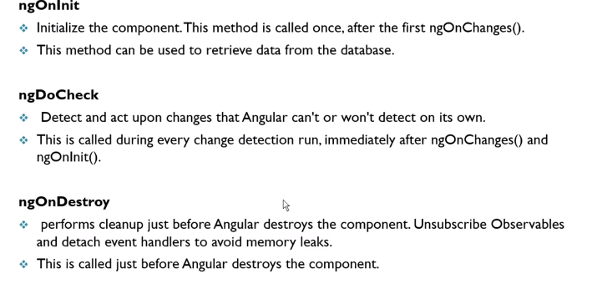

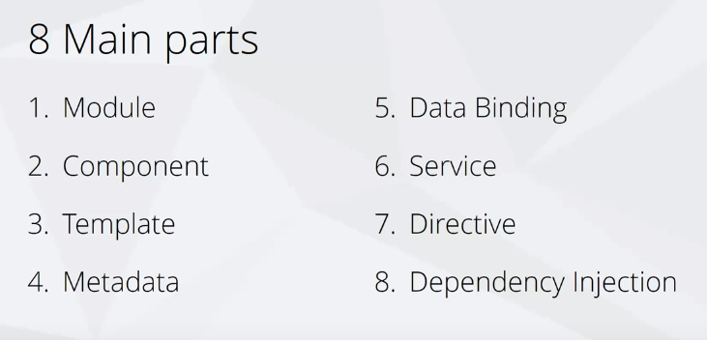

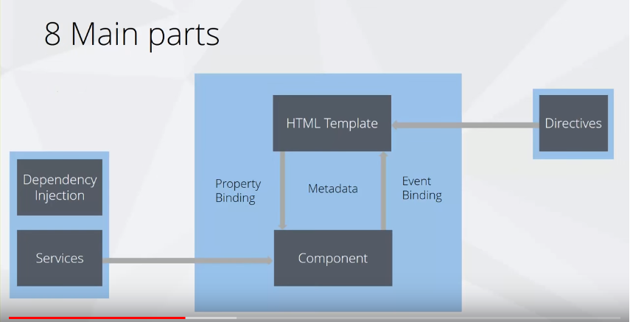

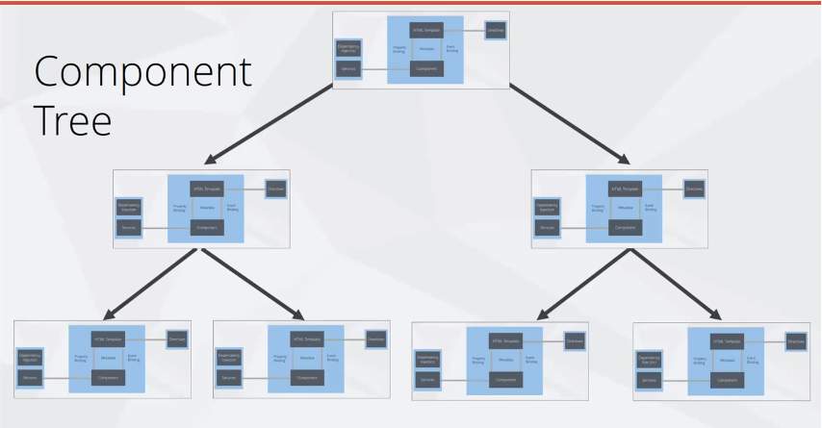

<https://angularfirebase.com/lessons/sharing-data-between-angular-components-four-methods/>

https://filipmolcik.com/angular-2-local-storage/

Recently I was implementing local storage in Angular2. I came across the marcj [**angular2-localstorage**](https://github.com/marcj/angular2-localstorage). He is using decorator which makes it super easy to save and restore automatically a variable state in local or session storage.